pd2-Taiko Report F74044046 蕭佑永

UML class diagram:

|  |
| --- |
| StartWindow |
| -GameInfo : GameWindow * |
| +StartWindow(parent=0 : QWidget *) :  +~ StartWindow() :  +Start_GameMode() : void |

|  |
| --- |
| GameWindow |
| +a : int  +b: int  + drum, forKeyuse: Drum *  + view: QGraphicsView *  + rect: QGraphicsRectItem *  + scene: QGraphicsScene *  + score: Score *  + Countdown, timer: QTimer *  + BackGround_Path, Drum1_Path, Drum2_Path: QString  + TimeCount, ScoreCount, timeRemain, LastScore, BackGround: QLabel * |
| +GameWindow(parent=0 : QWidget *) :  +~ GameWindow() :  +CountDown() : void  +EndGame() : void |

|  |
| --- |
| End |
|  |
| +End(parent=0 : QWidget *) :  +~ End() :  +restart() : void |

|  |
| --- |
| Drum2 |
| + Drum2_Path: QString |
| + Drum2 (parent=0 : QWidget *) :  +~ Drum2 () :  +restart() : void |

|  |
| --- |
| Drum1 |
| + Drum2_Path: QString  - Score: int |
| + increase(): void  + getScore(): int |

|  |
| --- |
| Drum |
| + Drum2_Path: QString |
| + move(): void  + spawn(): void  + *keyPressEvent*(event: QKeyEvent *): void  + Drumtype: int  + timer2: QTimer *  + Drum1_Path,Drum2_Path: QString |

Screen shot:

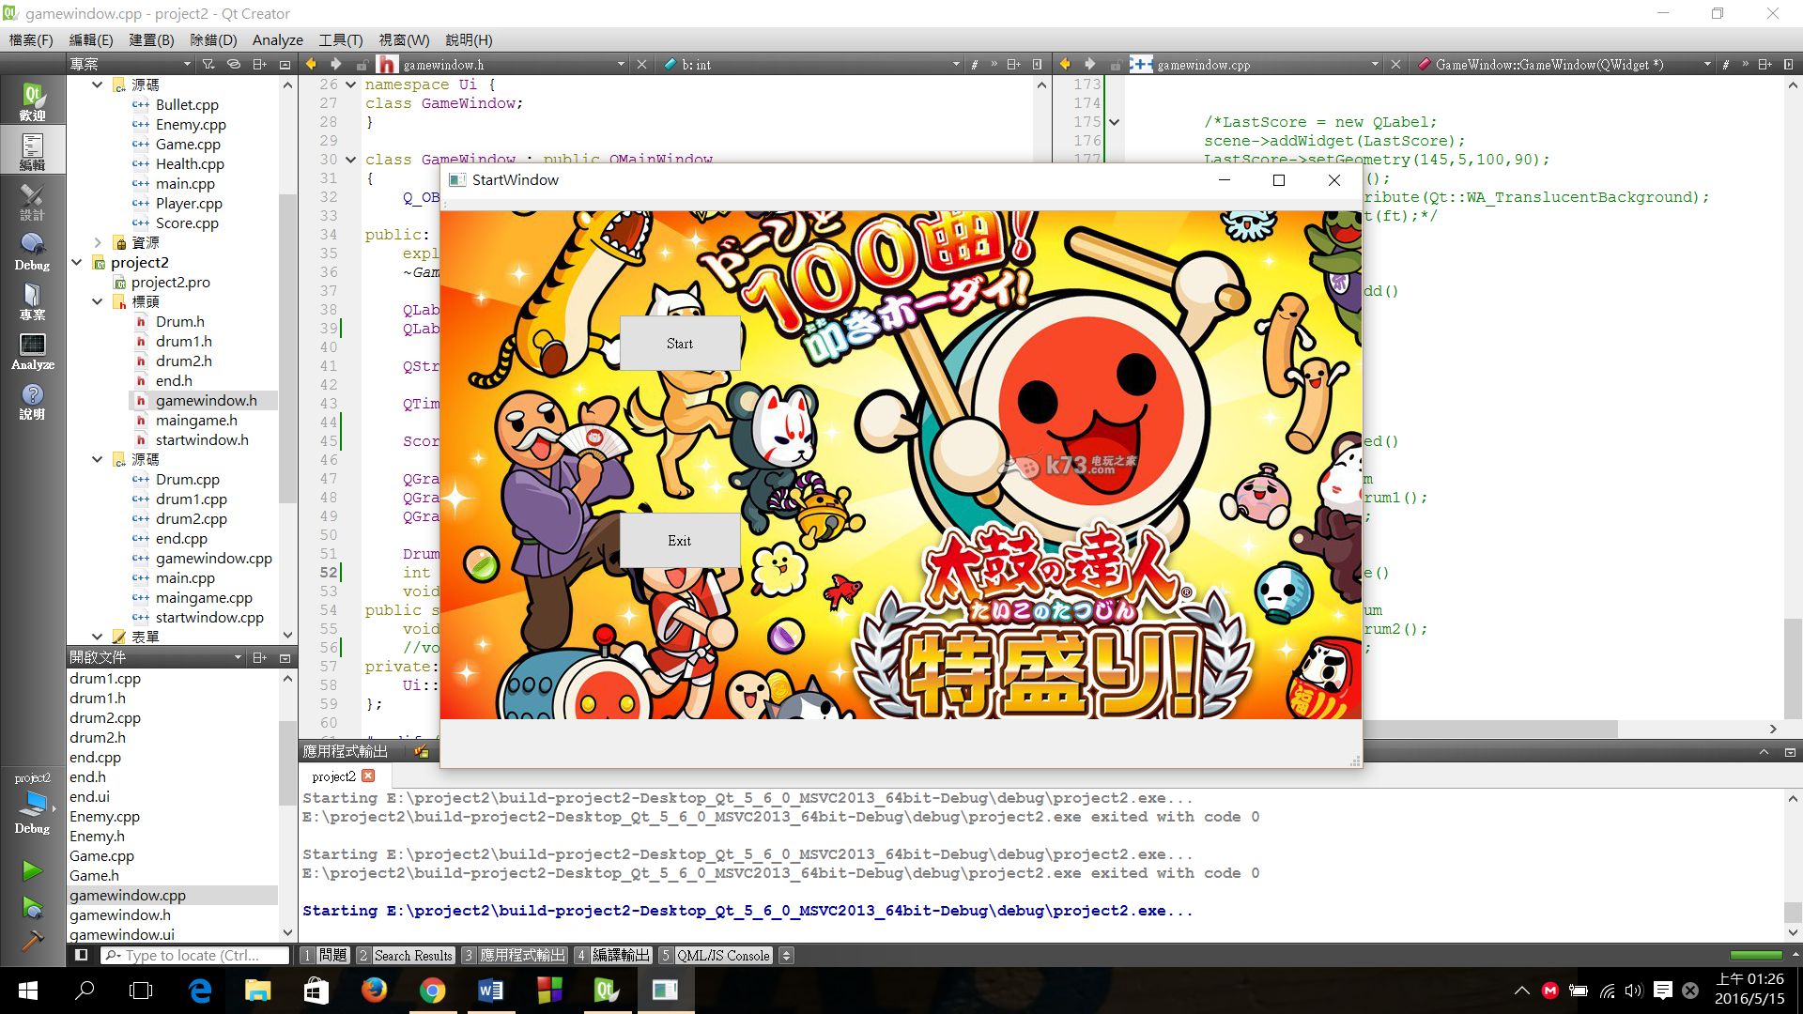

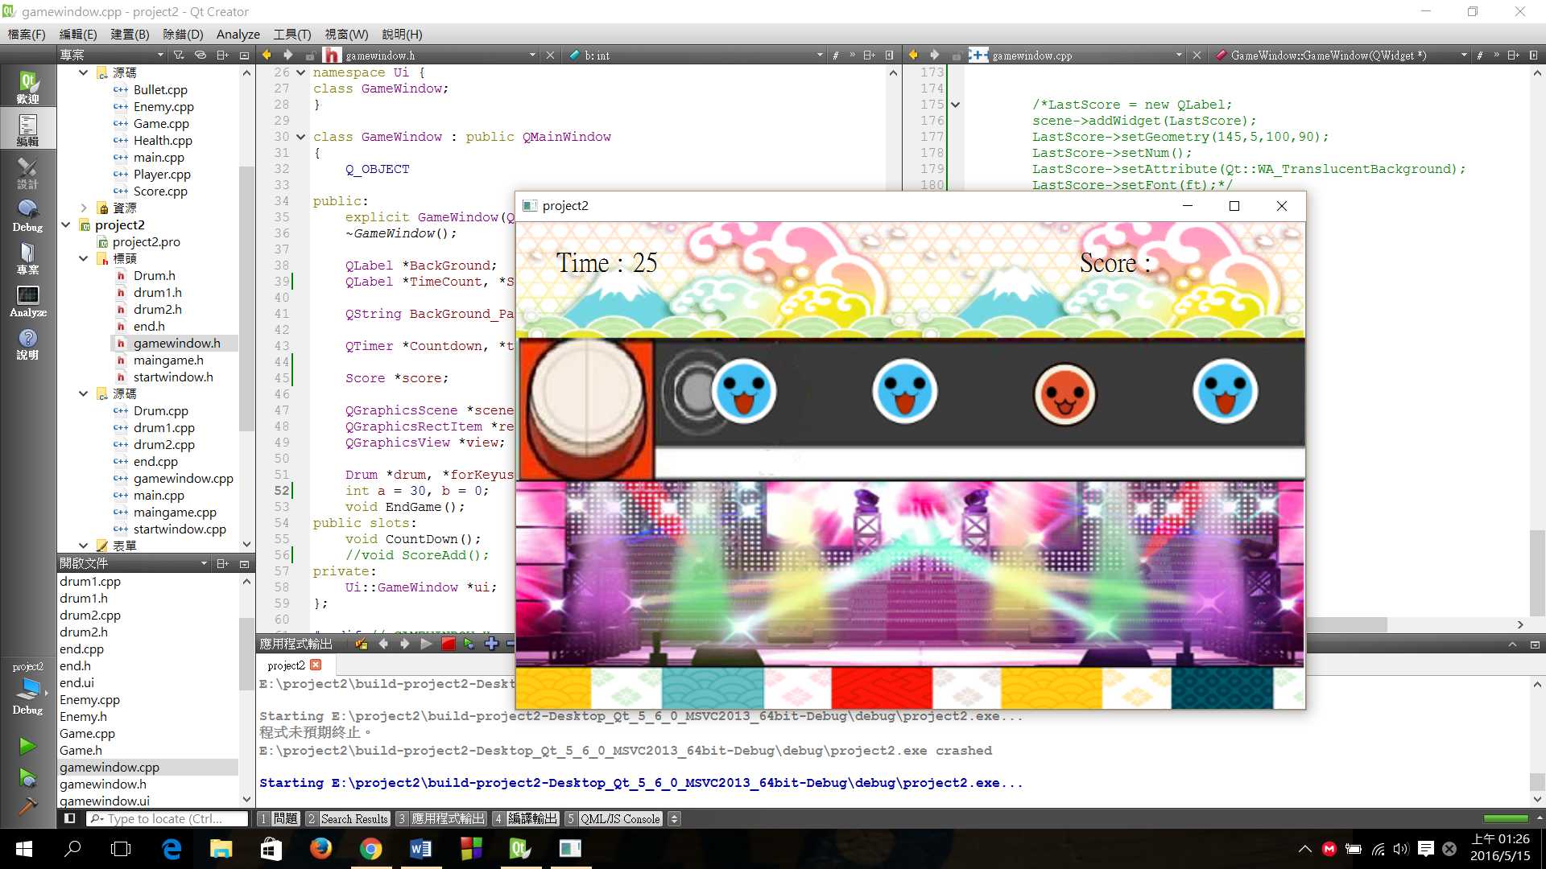

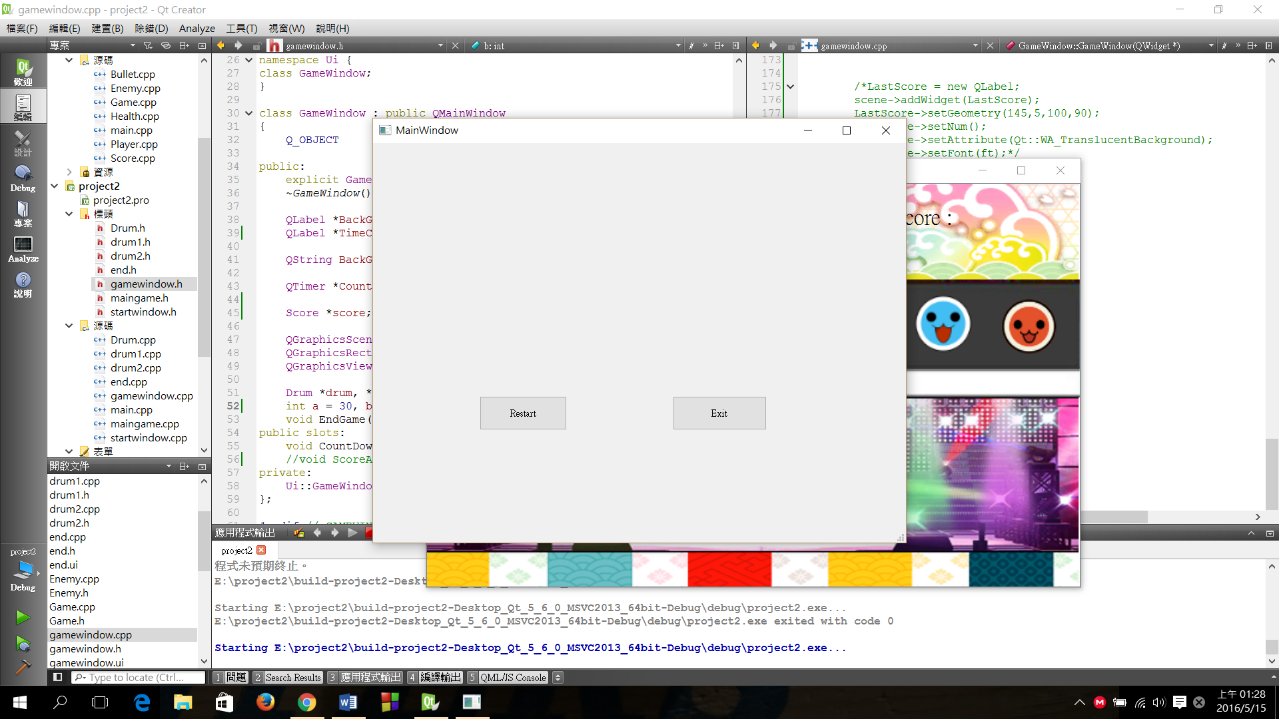

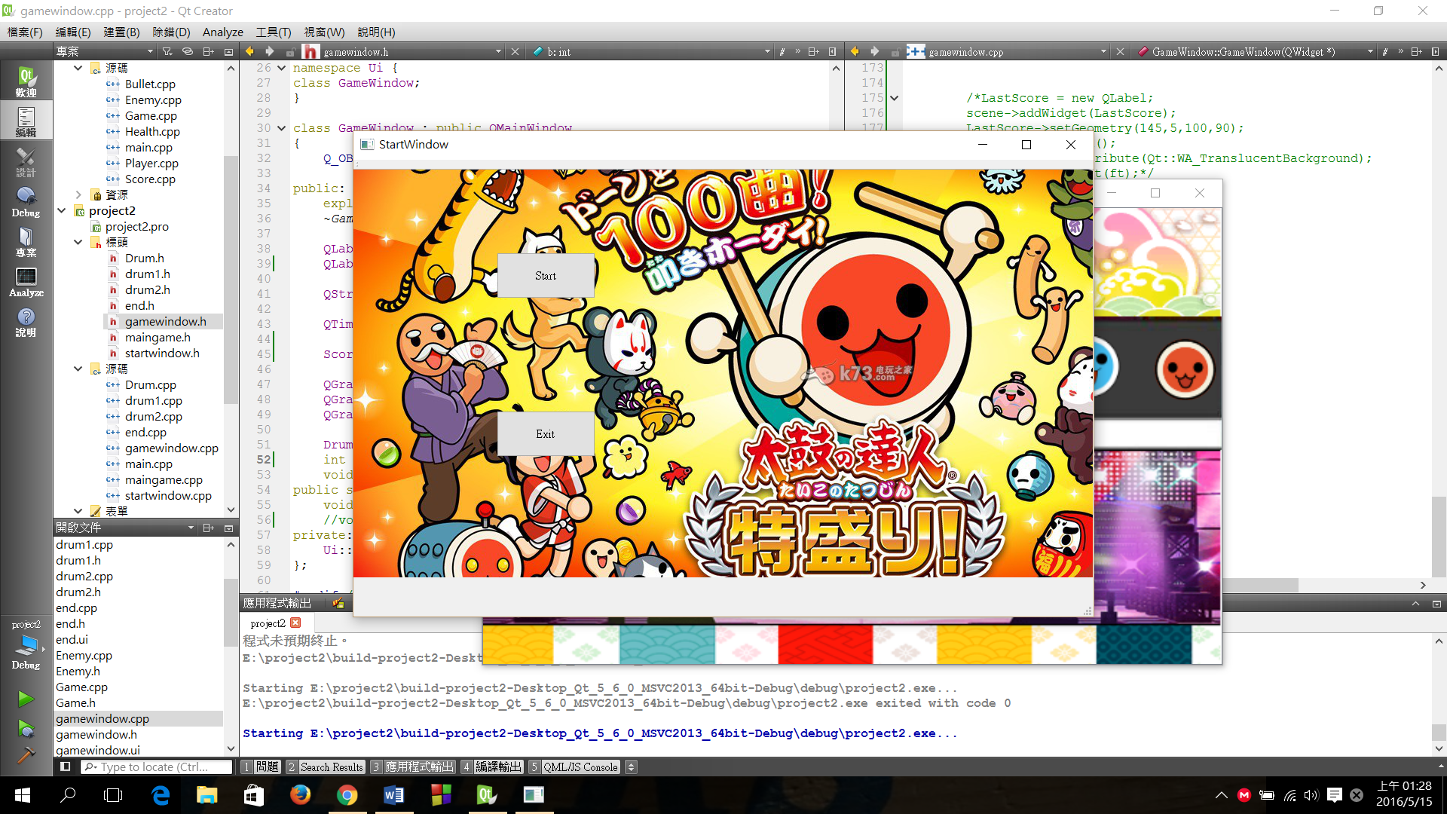

How to play:

按J可以消掉紅色鼓，按K可以消掉藍色鼓。在30秒內盡量把每一個鼓都消除！消除一個可以得一分。

Program architecture:

從StartWindow中的Start按鈕可連結到GameWindow，在GameWindow中是做對畫面的設定，在End中是做結算視窗的Restart跟Exit，Drum1是在做計算分數的部分，Drum中是在做鼓的生成和移動以及消除。